**Welcome to the MCCU App**

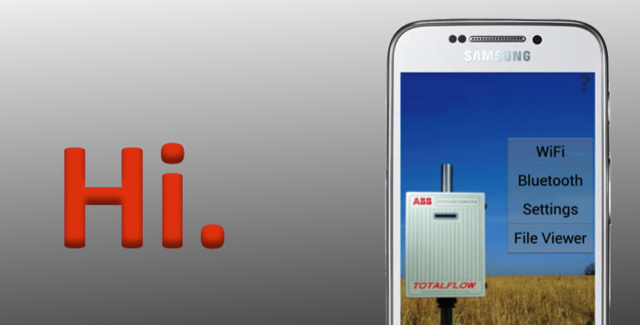

For starters, we need to cover a few key features of the MCCU application before you run wild. Please swipe the slide to continue.